**Monarch Butterflies**

Key Words for Searches

Butterfly Milkweed Fall Chrysalis

Monarch Migration Insect

Caterpillar Canada Egg

Danaus plexippus Mexico Caterpillar

Websites

* [Animal Facts: The Monarch Butterfly (KidZone)](http://www.kidzone.ws/animals/monarch_butterfly.htm) – This site has simple easy to understand descriptions of the monarch. Great pictures.
* [Monarch Butterfly Website](http://www.monarch-butterfly.com/) – This site has very detailed descriptions and a time-elapsed video of a monarch hatching. Great for older kids.
* [Monarch Butterfly USA](http://www.monarchbutterflyusa.com/Cycle.htm) – This site has wonderful detailed pictures. The descriptions are a little lengthy for young children but photos are worth a visit.
* [Insect Inspecta World](http://www.insecta-inspecta.com/butterflies/monarch/) – This site is one page on monarchs and might be a great research resource for older students.
* [GPNC.org](http://www.gpnc.org/monarch.htm) – This site has pictures to show the difference between male and female monarchs.
* [Monarch Migration Maps](http://www.learner.org/jnorth/monarch/) – Shows maps of where and when the monarchs migrate.

Dewey Decimal Categories

500 – Sciences

590 – Zoological Sciences

595.7 – Insects

Non-Fiction Books for Children

* *Monarch Butterflies* by Julie Murray (595.78 Mur) – Simple text introduces children to the lifecycle of the monarch.
* *Monarch Butterflies* by Helen Frost (595.78 Fro) – Introduces the physical characteristics and behaviors of monarchs.
* *Melody’s Mystery* by Diane Kelsay Harvey and Bob Harvey (595.78 Har) – A bilingual description of the monarch lifecycle.

[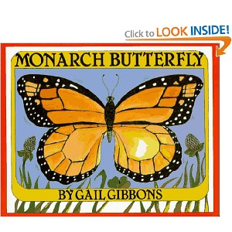](http://www.amazon.com/gp/reader/0823409090/ref=sib_dp_pt#reader-link)

* *Monarch Butterfly* by Gail Gibbons – Gail Gibbons delivers a vivid

description of the lifecycle and characteristics of monarchs.

[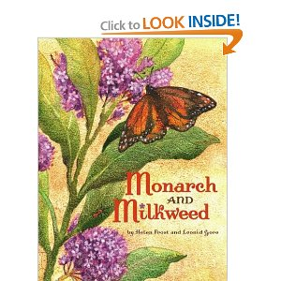](http://www.amazon.com/Monarch-Milkweed-Helen-Frost/dp/1416900853/ref=sr_1_3?ie=UTF8&qid=1301335688&sr=8-3)[](http://www.amazon.com/gp/reader/0823409090/ref=sib_dp_pt#reader-link)

* *Monarch and Milkweed* by Helen Frost – Simple description of the lifecycle of the monarch.

Fiction Books for Children

* *Monarch Butterfly* by Tracy Kompelien (E Kom) – The story of a caterpillar who organizes a sleepover at his school.
* *Butterfly House* by Eve Bunting (E Bun) – A girl and her grandfather build a house for larva and release them after they become butterflies. Every year afterward butterflies come to visit her.
* *Velma Gratch and the Way Cool Butterfly* by Alan Madison – A little girl who feels the need to live up to the high expectations set forth by her two older sisters has a life changing experience while on a field trip to a butterfly conservatory.

[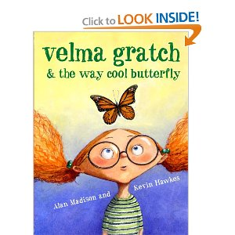](http://www.amazon.com/Velma-Gratch-Way-Cool-Butterfly/dp/0375835970/ref=sr_1_16?s=books&ie=UTF8&qid=1301336597&sr=1-16)[](http://www.amazon.com/gp/reader/0823409090/ref=sib_dp_pt#reader-link)

Periodicals for Children

* [Let’s Find Out](http://teacher.scholastic.com/products/classmags/lfo.htm)
* [National Geographic Kids](https://w1.buysub.com/pubs/NG/NWO/NoPremiumKIDSoffer10.jsp?cds_page_id=77786&cds_mag_code=NWO&id=1301337014609&lsid=10871330146040611&vid=1&cds_misc_5=KDSBNREDIT2)
* [Kids Discover](http://www.kidsdiscover.com/)

Videos

* *The Butterfly King* – This simple video describes the life cycle of the monarch.

[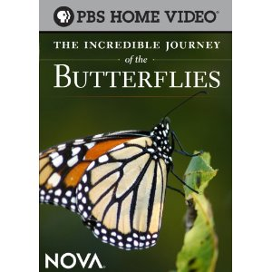](http://www.amazon.com/Incredible-Journey-Butterflies-n/dp/B001RV53TE/ref=sr_1_1?ie=UTF8&s=dvd&qid=1301337650&sr=8-1)[](http://www.amazon.com/Velma-Gratch-Way-Cool-Butterfly/dp/0375835970/ref=sr_1_16?s=books&ie=UTF8&qid=1301336597&sr=1-16)[](http://www.amazon.com/gp/reader/0823409090/ref=sib_dp_pt#reader-link)

* *The Incredible Journey of the Butterflies* – PBS documentary of the monarch migration.

Images

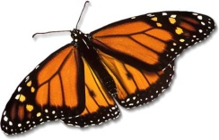 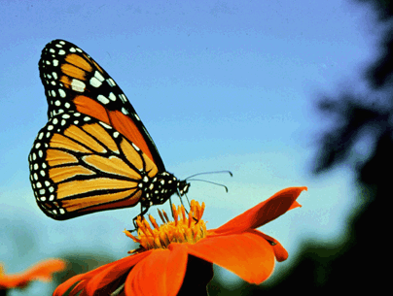 [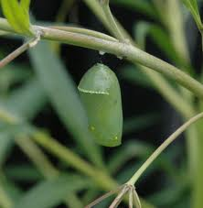](http://www.google.com/imgres?imgurl=http://ed101.bu.edu/StudentDoc/current/ED101sp09/richebay/Monarch_Butterfly_Chrysalis.JPG&imgrefurl=http://ed101.bu.edu/StudentDoc/current/ED101sp09/richebay/monarch%2520butterfly.html&usg=__dxHS-w1hI5Qpt9lgQ4A7OWvvYlk=&h=1024&w=1004&sz=145&hl=en&start=53&zoom=1&tbnid=HtlhqvCqEuWcPM:&tbnh=143&tbnw=139&ei=PNeQTY6GNJSrcdODwPgJ&prev=/images%3Fq%3Dmonarch%2Bbutterfly%26um%3D1%26hl%3Den%26sa%3DX%26biw%3D1276%26bih%3D628%26tbs%3Disch:1&um=1&itbs=1&iact=rc&dur=0&oei=E9eQTdK4O4m2twfk86mICQ&page=4&ndsp=18&ved=1t:429,r:7,s:53&tx=75&ty=34) 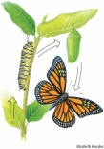 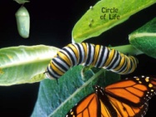 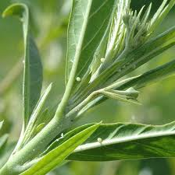 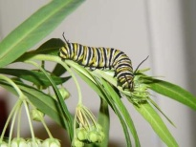

Lesson Resources for Teachers

* [The Teacher’s Guide](http://www.theteachersguide.com/butterflies.htm)
* [Monarch Butterflies for Grades K-2](http://teachers.net/lessons/posts/393.html)
* [Biographies of a Butterfly for Grades 1-2](http://www.atozteacherstuff.com/pages/277.shtml)
* [Monarch Butterfly Life cycle for Grades K-2](http://www.glorious-butterfly.com/elementary-lesson-plans.html)