**Winter**

Keywords

Winter

Snow

Blizzard

White-out

Sub-Zero temperatures

Ice

Frozen

Cold

Seasons

Frost

El Nino

Ice Crystals

Slush

Brine

Icicles

Glaciers

Websites

* *For Teachers*
* [NOAA Education Resources](http://www.noaanews.noaa.gov/stories2009/20091015_winteroutlook.html) - Gives a nice description about how El Nino affects winter weather.
* [Winter Fun](http://www2.scholastic.com/browse/collection.jsp?id=125) - This website is from Scholastic and offers many valuable resources for Kindergarten and second grade teachers. Several of the recources can be used in the classroom and others are simply articles that can aid in giving the teacher a better understanding of winter weather.
* *For Students*
* [*FEMA For Kids](http://www.fema.gov/kids/wntstrm.htm) - This website gives definitions for winter weather terms. It also has a downloadable book about winter disasters and gives winter safety tips to kids that they can share with their families.
* [The Weather Maker](http://teacher.scholastic.com/activities/wwatch/investigate/weather_maker.htm) - This activity allows students to adjust the temperature at the equator, the pole temperatures, and the humidity of an environment to see what happens to the weather. As you change the weather an explanation of what is happening is given.
* [Weather WizKids](http://www.weatherwizkids.com/weather-winter-storms.htm) - This website is developed by a meteorologist to help children understand weather. The page bookmarked is a very good explanation of winter storms.

Dewey Decimal Categories

500 - Sciences

550 - Earth Sciences

551 - Geology, Hydrology, Meteorology

Non-fiction Books for Children

[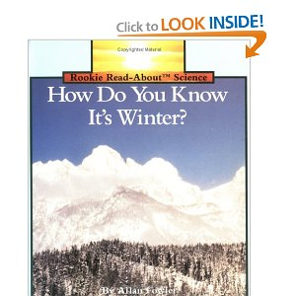](http://www.amazon.com/Know-Winter-Rookie-Read-About-Science/dp/051644915X/ref=sr_1_13?s=books&ie=UTF8&qid=1290396814&sr=1-13#__)

* *How Do You Know It's Winter?* - This book describes various aspects of winter using photographs instead of illustrations.

[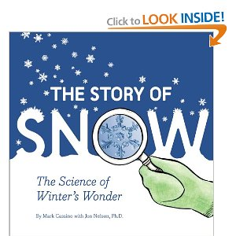](http://www.amazon.com/Story-Snow-Science-Winters-Wonder/dp/0811868664/ref=sr_1_19?s=books&ie=UTF8&qid=1290397390&sr=1-19)

* *The Story of Snow* - A vivid description of how snow is formed.

[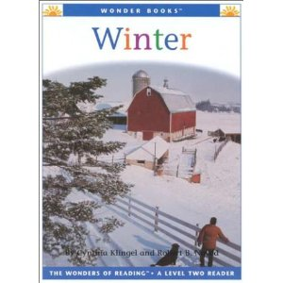](http://www.amazon.com/Winter-Wonder-Books-Level-Seasons/dp/1567668127/ref=sr_1_1?s=books&ie=UTF8&qid=1290480070&sr=1-1)

* *Winter* - This book describes the characteristics of winter as well as the changes that occur throughout the Earth.
* *When Winter Comes* - this book not only looks at the characteristics of winter but also describes activities that children do during the winter.

[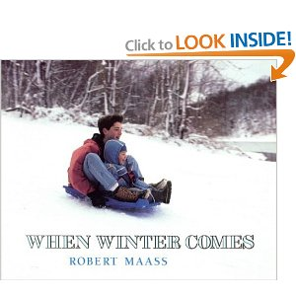](http://www.amazon.com/When-Winter-Comes-Owlet-Book/dp/0805049266/ref=sr_1_1?ie=UTF8&s=books&qid=1290480682&sr=1-1)

Fiction Books for Children

* [One Winter's Day](http://www.amazon.com/One-Winters-Day-Christina-Butler/dp/1561485322/ref=sr_1_8?s=books&ie=UTF8&qid=1290396814&sr=1-8) - After Little Hedgehog's nest blows away he embarks on a journey to his friend Badger's house and meets several very cold animals that he helps along the way.
* [Winter Days in the Big Woods](http://www.amazon.com/Winter-Woods-First-Little-House/dp/0064433730/ref=sr_1_29?s=books&ie=UTF8&qid=1290397588&sr=1-29) - This book is a simpler version based on the Little House On the Prarie book series by Laura Ingalls Wilder.
* [The Hat](http://www.amazon.com/Hat-Jan-Brett/dp/0399231013/ref=sr_1_1?s=books&ie=UTF8&qid=1290479688&sr=1-1) - This book, by Jan Brett, follows a curious hedgehog after he pokes his noe into a woolen stocking.
* [It's Winter](http://www.amazon.com/Winter-Celebrate-Seasons-Linda-Glaser/dp/0761316809/ref=sr_1_1?s=books&ie=UTF8&qid=1290396814&sr=1-1) - This book gives a good overview of the winter season and includes more information that simply describing the weather.

Videos

* [The Four Seasons](http://www.amazon.com/Four-Seasons-VHS-100-Videos/dp/1585410535/ref=sr_1_1?ie=UTF8&s=books&qid=1290540321&sr=8-1-catcorr) - This video discusses the changes that occur in all four seasons.
* [Ice Age](http://www.amazon.com/Ice-Single-Disc-Denis-Leary/dp/B0006UEVT0/ref=sr_1_1?s=dvd&ie=UTF8&qid=1290540496&sr=1-1) - This movie follows a mastodon, a sloth, and a saber-toothed tiger as they embark on a journey to reunite a human baby with his father.
* [Ice Age 2: The Meltdown](http://www.amazon.com/Ice-Single-Disc-Denis-Leary/dp/B0006UEVT0/ref=sr_1_1?s=dvd&ie=UTF8&qid=1290540496&sr=1-1) - This movie follows the mastodon, sloth, saber-toothed tiger and various other new characters on a journey to find a boat that will save them from the great ice meltdown.
* [Eight Below](http://www.amazon.com/Eight-Below-Full-Screen-Walker/dp/B000F4PDF8/ref=sr_1_1?s=dvd&ie=UTF8&qid=1290541715&sr=1-1) - This movie follows a man's journey to rescue his eight beloved dogs stranded in Antarctica.

Images

[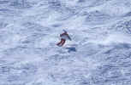](http://wikis.rcoe.appstate.edu/MediaPedia/index.php/File:Skiing_Image.jpg) [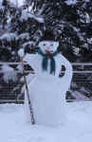](http://wikis.rcoe.appstate.edu/MediaPedia/index.php/File:Snowman_Image.jpg) [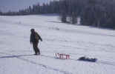](http://wikis.rcoe.appstate.edu/MediaPedia/index.php/File:Sleding_Image.jpg) [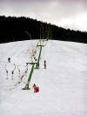](http://wikis.rcoe.appstate.edu/MediaPedia/index.php/File:Ski_Slope_Image.jpg) [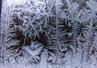](http://wikis.rcoe.appstate.edu/MediaPedia/index.php/File:Ice_Crystals_Image.jpg) [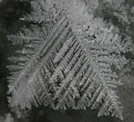](http://wikis.rcoe.appstate.edu/MediaPedia/index.php/File:Slush_Image.jpg)

Lesson Resources for Teachers

* [Snow Stars](http://www.freekidcrafts.com/snow-stars.html) - This sight gives step-by-step directions to make snowflakes from paper.
* [Cotton Ball Snowman Craft](http://www.allkidsnetwork.com/crafts/winter/cotton-ball-snowman.asp) - This is a cute snowman craft that will be very easy to display on a bulletin board.
* [Snowy Handprint Tree](http://crafts.kaboose.com/snowy-handprint-tree.html) - These are great keepsakes for parents because it includes a handprint.
* [Homemade Snow Dough](http://familyfun.go.com/winter/winter-crafts/more-winter-crafts/homemade-snow-dough-796115/) - Almost everyone likes to play with play dough and when you help make sparkly play dough it's even more fun.
* [Winter Sun Catcher](http://familyfun.go.com/winter/winter-crafts/more-winter-crafts/winter-sun-catcher-824949/) - This craft can include some science experimenting with ice because the sun catchers are made of ice.
* [Winter - Teacher Resources](http://www.teachervision.fen.com/winter/teacher-resources/6677.html) - This website gives many resources for winter lesson plans.
* [Ultimate Winter Resource For Teachers](http://www.teachingheart.net/xmas.html) - This website includes many winter lesson ideas for teachers as well as ideas for breaking the theme of winter into subcategories.
* [Winter Idea Book](http://www.amazon.com/Winter-Idea-Book-Scholastic/dp/0439499615/ref=sr_1_15?s=books&ie=UTF8&qid=1290396436&sr=1-15) - Contains patterns, crafts, activities, and ideas to explore winter weather.
* [Reading Language and Math Ideas: Winter](http://www.amazon.com/Reading-Language-Math-Activities-Winter/dp/1420638890/ref=sr_1_18?s=books&ie=UTF8&qid=1290396537&sr=1-18#_) - This book gives ideas for extensions to a science winter unit as well as ways that you can integrate.
* [Glide Into Winter With Math and Science](http://store.aimsedu.org/aims_store/books/glide-into-winter.html) - This book has a lot of experiements to use to learn about winter weather. It also has many ideas for integrating several instructional areas.