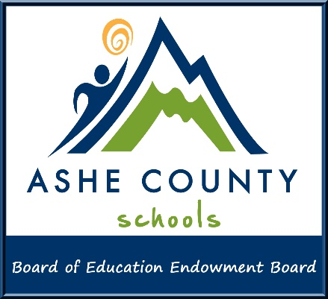

**Memo**

# To: From: Date: Re:

Educators

ACS Endowment Grant Committee

January 6, 2025

# Grant opportunity - 2025 Endowment Fund Grant Applications

# The Endowment Board is pleased to announce funds available to award in grants for the 2025/26 school year.

Ashe County Board of Education Endowment Fund is a nonprofit organization that enables new and innovative approaches to learning that are not supported through the traditional funding of public education. Money placed in the fund is used to support these new and innovative approaches by providing grants to educators in our county’s schools.

The Ashe County Board of Education Endowment Board has established the following timetable for the 2025 Grants.

**Jan. 6, 2025** –Application period opens

**March 17, 2025, 5:00 PM** –Submission due date for Grant Applications

**May 5, 2025** – Presentation of the grant award recommendations to the Ashe County Board of Education for consideration and approval; **May 6, 2025** – Notify award recipients

**June 2, 2025** –Recognition of grant recipients at the regularly scheduled Ashe County Board of Education meeting

**June 2, 2025** – Project evaluation due from 2024/25 grant recipients

**July 1- September, 2025** – Disbursements will be made to the recipients of the 2025

Endowment Fund Grants

**August 2025** – **May 2026** – 2025 grant funds must be spent and implemented during

the 2025/26 school year

The 2025 Endowment Fund Grant Application and a list of frequently asked questions have been posted on Ashe County Schools website. *Click on the “Teachers & Staff” tab, then select “Endowment Board” from the directory. Or click here:* [*https://www.asheschools.org/Page/2738*](https://www.asheschools.org/Page/2738)*.*

**The application will open in word. Please save to your computer. To complete the application please open the saved copy on your computer. You may type on that copy.**

Remember the following tips when completing the application:

* Projects that are ongoing year after year are more likely to be funded than a project request for only one year.
* Projects that serve a large number of students are more likely to be funded.
* Make sure project is innovative, meets the needs of students served and provides something/things your school cannot.
* Place your cursor within the [ ] to begin typing (applications must be type-written).
* Your responses must fall within the allowable number of words.
* Responses should be well written and each area clearly defined and detailed.
* Correct spelling and grammar are a must.
* Proofread the application for errors (spelling, grammar and mathematical figures). Errors will lower the total score.
* Please do not use acronyms unless they are explained in the narrative (non- school personnel may be evaluating these grant applications and would not be familiar with school lingo).
* Under section IV Budget and Funding be sure to:
  + include the description/names of the items you are requesting (part/ model numbers are insufficient)
  + indicate if the items requested are mandatory for implementing your grant project
  + specify an amount if partial funding is checked
  + maximum award per Endowment Fund Grant is **$1,500.00.**
* Evaluation of your proposal/project is required once it is completed. An evaluation form will be provided for you to complete and submit to the Endowment Board.

When you have finished the application, please print, and **ask your principal to review and sign.** Email the signed application to Rhonda Smith at Central Support Services via email ([rhonda.smith@ashe.k12.nc.us](mailto:rhonda.smith@ashe.k12.nc.us)). Or, you may send to her through school mail or hand deliver to her at the Central Support Services office. **Deadline is** **March 17, 2025 at 5 PM.**

If you have questions, please do not hesitate to contact Rhonda at Central Support Services,  
(336) 246-7175.